Explore Azure Database for PostgreSQL

In this exercise you’ll provision an Azure Database for PostgreSQL resource in your Azure subscription.

This lab will take approximately **5** minutes to complete.

Before you start

You’ll need an [Azure subscription](https://azure.microsoft.com/free) in which you have administrative-level access.

Provision an Azure Database for PostgreSQL resource

In this exercise, you’ll provision an Azure Database for PostgreSQL resource.

1. In the Azure portal, select **＋ Create a resource** from the upper left-hand corner and search for *Azure Database for PostgreSQL*. Then in the resulting **Azure Database for PostgreSQL** page, select **Create**.
2. Review the Azure Database for PostgreSQL options that are available, and then in the **Azure Database for PostgreSQL** tile, select **Flexible server (Recommended)**, then **Create**.

[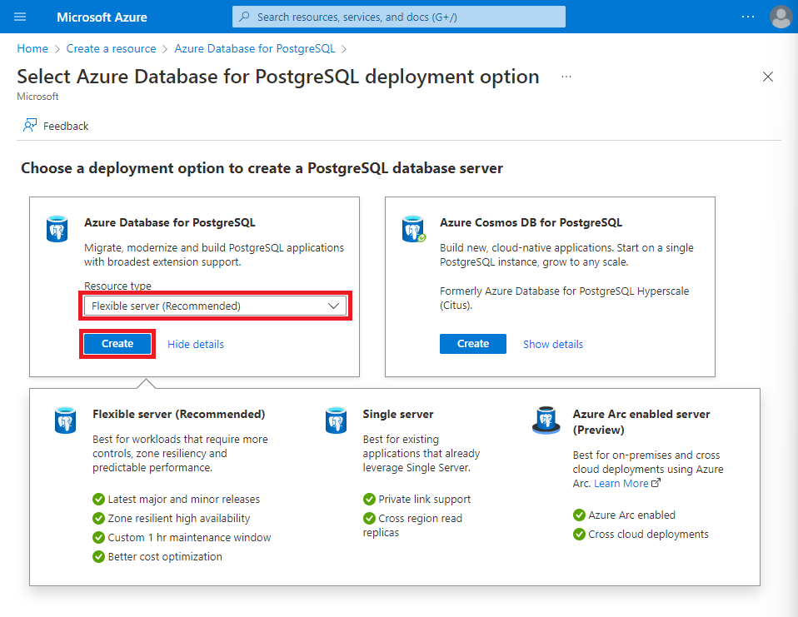](https://microsoftlearning.github.io/DP-900T00A-Azure-Data-Fundamentals/Instructions/Labs/images/postgresql-options.png)

1. Enter the following values on the **Create SQL Database** page:
   * **Subscription**: Select your Azure subscription.
   * **Resource group**: Create a new resource group with a name of your choice.
   * **Server name**: Enter a unique name.
   * **Region**: Select a region near you.
   * **PostgreSQL version**: Leave unchanged.
   * **Workload type**: Select **Development**.
   * **Compute + storage**: Leave unchanged.
   * **Availability zone**: Leave unchanged.
   * **Enable high availability**: Leave unchanged.
   * **Admin username**: Your name.
   * **Password** and **Confirm password**: A suitably complex password.
2. Select **Next: Networking**.
3. Under **Firewall rules**, select **＋ Add current client IP address**.
4. Select **Review + Create**, and then select **Create** to create your Azure PostgreSQL database.
5. Wait for deployment to complete. Then go to the resource that was deployed, which should look like this:

[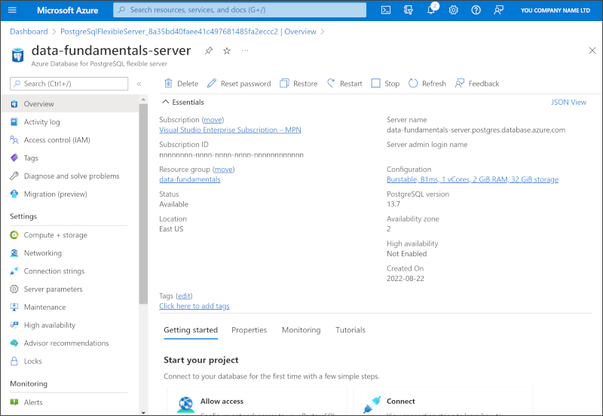](https://microsoftlearning.github.io/DP-900T00A-Azure-Data-Fundamentals/Instructions/Labs/images/postgresql-portal.png)

1. Review the options for managing your Azure Database for PostgreSQL resource.

**Tip**: If you’ve finished exploring Azure Database for PostgreSQL, you can delete the resource group that you created in this exercise.